NorDig guidelines and recommendations for TV Accessibility
Accessibility for visually, hearing and motor impaired users of live and Ondemand TV

1. Introduction
2. Background
3 General accessibilty requirements
legislation and best practise, refences to EU, DVB, EBU and DTG
4. Accessibilty services - user groups and type of services
4.1 For blind and visually impaired
4.2 For deaf and hard of hearing
4.3 For users with reduced motor abilities
5. NorDig supported accessibility services
5.1 NorDig specifications and requirements
5.2 Metadata
5.3 EPG
5.4 HbbTV based accessibilty services cross platform
6. Guidelines and recommendations for accessibility services
The different services and function types

7. Where and how to find information about tv programs with accessibility services
Program guide onscreen and on print
7.1 EPG – onscreen program guide
7.2 Information on print
7.3 Icons for accessibility services - non bitmaps
8. How and where to find accessibility services
onscreen menu structures
9. User interfaces for accessibility services
how to navigate and access accessibility services
9.1. Accessibility friendly navigation
9.2 Accessibility friendly remote control
9.3 Accessibility friendly smart wands
9.4 Accessibility friendly voice control
9.5 Alternative Accessible Navigation Methods
10. Documentations and user guidelines
11. Universal interface for an Accessibility friendly remote-control
Proposal for Universal interface based on Bluetooth
Annex B: DR smart icon design
Annex B: Links for reference and more information

Introduction
This document “NorDig guidelines and recommendations for TV Accessibility”, is about accessibility on Live and Ondemand TV for users with physical disabilities with a special focus on accessibility friendly navigation and user interfaces for accessibility services - how to find and access the accessibility services.
This NorDig document aims to support manufacturers, broadcasters, distributors and others by guidelines and recommending for technical best possible accessibility services and solutions for live and Ondemand tv.
Guidelines and recommendations in this document are based on NorDig specifications and recommendations and cooperation with DTG and other European sister organisations.
User surveys in the Nordic region among users of accessibility services have shown that there is awareness of existing accessibility services on TV, but there are typically challenges in finding and accessing the services via on-screen menus via the remote control. Therefore, we seek to share knowledge here to improve the conditions for users of accessibility services so that they have better opportunities to access accessibility services on live and Ondemand TV that support their special needs.
NorDig released “NorDig Accessibility Package ver. 1.0” November 2024”, this document is included in ver. 2.0, a follow-up to the first release which includes more guidelines and recommendations regarding TV accessibility with a focus on the users.

This document tries to cover the accessibility area from a practical and operational perspective based on the specific needs of users in relation to the limitations of various physical disabilities.

Background (focus on users with disabilities, needs and challenges)
It is often difficult for people with physical disabilities to access accessibility services with a remote control to interaction with the screen and setup in special menus, as the user need an accessibility friendly remote-control that supports the special user need, and on-screen information that make it possible to find and access the services.

Many accessibility services have been implemented and have been in operation for many years, which are based on existing specifications, but the technical development with the possibility of, for example, switching between live and OnDemand presents challenges in terms of finding and using the services.
NorDig has found that there is a need for a comprehensive document that can cover the accessibility area as broadly as possible with guidelines and recommendations to help with the implementation of existing and develop new and better accessibility services.
The technical development provides the opportunity for better and more easily accessible accessibility services cross platform, which should be exploited for the benefit of users with physical disabilities and limitations.

General accessibilty requirements
(legislation and best practise, refences to DVB and DTG)

Accessibilty services - user groups and type of services
This document is focusing on accessibility for the following user groups including users who may have several different disabilities:
      - Blind and visually impaired
- Deaf and hard of hearing
- Users with reduced motor abilities.
User groups with different physical handicaps and relevant types of TV accessibility services:
4.1 For blind and visually impaired
- Voice control of receiver functions
- Audio Description
- Spoken input
- Text-to-speech assisted input
4.2 For deaf and hard of hearing
- Subtitles
- Sign language
- Clear speech
4.3 For users with reduced motor abilities
- Big buttons with clear markings for function and logical placement on the remote control.

NorDig supported accessibility services (links to IRD and RoO spec.)
5.1 NorDig specifications and requirements
NorDig specification requirements support as minimum the requirements in the EU regulations about accessibility for consumer IRDs /TV receivers.
NorDig supports following types of accessibility services for broadcast TV & radio services:
- Audio Description (AD)
- Spoken Subtitles (SpS)
- Dialogue Enhancement (DE)
- Hard of Hearing Subtitles (HH)
- Audio Description subtitles (ADS)
- HbbTV accessibility services
Broadcasters may sometimes use one combined stream for several accessibility services (e.g. one common extra audio stream / PID for both AD and SpS, where for some program events it is used for AD and some others for SpS).
For more information see “Accessibility services supported in NorDig IRD and RoO specifications ver. 3.2.2” where is listed all accessibility services supported in NorDig specifications (NorDig Unified Requirements/IRD, and NorDig Rules of Operation/RoO) v. 3.2.2, the document includes a list of where to find relevant chapters for the different kind of accessibility services.
5.2 Metadata
NorDig TVA metadata exchange format is based on TV Anytime specification with includes NorDig requirements. The TVAnytime specification includes the possibility to handle metadata description of all kinds of accessibility services related to a program / content for live and Ondemand tv.
5.3 EPG

5.4 HbbTV based accessibilty services cross platform
NorDig IRDs supports HbbTV enabling the possibility to handle accessibility services based on HbbTV.
HbbTV gives the possibility to develop and distribute advanced accessibility services cross platforms so the accessibility services will look and function in the same way on any NorDig IRDs supporting HbbTV, which can be a great advantage for users of accessibility services with special needs.
For more information see separate NorDig document “Accessibility services based on HbbTV”, The document includes information, recommendations and implementation guidelines concerning accessibility services based on HbbTV, and where to find more knowledge about accessibility services based on HbbTV including experience with HbbTV accessibility services “On Air” in Germany.

Guidelines and recommendations for accessibility services - different services and function types

Where and how to find information about tv programs with accessibility services
Program guide onscreen and on print
7.1 EPG – on-screen program guide
7.2 Information on print
7.3 Icons for accessibility services - non bitmaps
Icons used for accessibility services on tv, like AD (audio Description) on-screen are mostly bitmaps “pictures” like recommended in W3C for web accessibility. The use of icons as bitmaps / pictures complicated in distribute and the look alike are not standardised so accessibility icons can look very different which does not make it easier for the disabled users.
7.3.1 Proposal for using DR smart icons for accessibility services
The icons are designed so they can be typed as text on a keyboard - like the classic smiley :-). which makes accessibility icons easily manageable via database in plain text, since it is not necessary to use bitmaps.
DR smart icons are developed in 2013 and implemented in 2014 in EPG, Onscreen and in all printed media / papers in Denmark. The Icons was presented for EBU at Madrid meeting 2018 as proposal for common standard.
https://www.dr.dk/om-dr/about-dr/smart-icons-design-common-european-standardization
See annex A for more information

How to find and access the accessibility services - on-screen menu structure

Accessibility friendly navigation
9.1 Accessibility friendly remote control
User surveys show that there is a general problem with accessibility-friendly remote controls, the trend of modern remote-control designs with a minimum of buttons can make it impossible for users with disabilities to access the accessibility services they need.
Help is often required from people who are not disabled to find and select accessibility services for the user who need the services.
It makes it even more difficult / impractical that it´s not always possible to create a fixed setup in an IRD / TV set with a usable accessibility profile, so for example, an accessibility service disappears when switching from one TV channel to another.

Specification of accessibility friendly remote-control for accessibility services that can be used by users with different types of disabilities for easier access of tv accessibility services.
NorDig have prepared this specification, learned from several user surveys, including a NorDig user survey in member countries conducted in 2024, has been shown that users of accessibility services often have difficulty finding and accessing relevant accessibility services via the TV remote control.
A accessibility friendly remote-control shall have a simple design and without technical challenges for the consumer to find, connect and access accessibility services on the TV/IRD’s.
Accessibility friendly remote-control means, a remote control with buttons / physical user interface (including sounds) for the specific standardised accessibility services such as subtitles for hard of hearing, spoken subtitles, audio description etc.
Note: NorDig specify an accessibility friendly remote-control for accessibility services on tv, but will not be commercial involved in production of a remote-control product.
9.1.1 Description of buttons and functions
9.1.1.2 Subtitles (ref. U-Book A1.4.15)
This button should toggle between displaying subtitles (if available with the selected service) and not displaying them. The function should be available directly from the remote control.
Note that the receiver should maintain the selected state ("display"/"don't display" subtitles) across channel changes unless otherwise determined by a user-setting in a suitable set-up menu.
Subtitles and Audio Description (AD) (ref. U-Book A4.8.2)
When subtitle or AD mode is active it should remain active when channels are changed.
9.1.1.3 Audio Description (ref. U-Book A1.4.11)
This button should control the decoding of Audio Description (AD) if available with the selected service and event and if the receiver supports AD.
The button should toggle between presenting AD mixed with programme sound or just presenting programme sound.
The receiver may be capable of directing the mix to independent audio outputs (e.g. phono and/or headphone), in which case this function controls the relevant output.
The function should be available directly from the remote control if the receiver supports AD.
If selection of AD requires accessing a setup screen, it is recommended that AD be the dominant item so as to simplify selection by a user who cannot see the screen clearly.
The digital receiver should maintain the selected state ("present AD"/"don't present AD") across channel changes unless otherwise determined by a user-setting in a suitable set-up menu.

9.1.1.4 Voice Control (ref. U-Book A1.5)
This button should activate/deactivate a voice control microphone incorporated into the remote control.

9.2 Accessibility friendly smart wands
Text-to-speech assisted input (ref. U-Book A1.10.4)
Some users, in particular blind and partially-sighted users, may benefit from text entry using the numeric keys on the remote control assisted by the text-to-speech engine.
As characters are entered, the text-to-speech engine provides spoken feedback on the text entered.
9.3 Accessibility friendly voice control
9.3.1 Voice control of receiver functions (ref. U-Book A1.11)
Voice control of receivers can be provided through voice remote controls or other voice assistants. Where remote controls are used that require a button to be pressed before the voice system operates, consideration should be given to users who have reduced motor skills.
9.3.2 Spoken input (ref. U-Book A1.10.3)
Some solutions allow for spoken input (using automatic speech recognition, ASR) as an alternative to text input. This can improve the accessibility of text entry for some categories of disabled people, but this is not a solution that will work for all users and should therefore not be seen as the sole alternative to standard input methods.
A combination of a voice control facility for text entry and a text to speech function for confirmatory feedback of text entered can be beneficial to visually-impaired users.
9.4 Alternative Accessible Navigation Methods

9.5 Other considerations (ref. U-Book A1.12)
Where a remote control is based on the use of a touch screen, this should not be the only means of controlling the receiver: the use of such devices can be difficult for those with limited control of hand movements or single-handed.

Documentations and user guidelines
10.1 User documentation (ref. U-Book A2.)
10.2 General (ref. U-Book A2.2.1)
User guides should be easy to read, concise and jargon-free. They should avoid technical abbreviations and have a design and content that will be accessible to most users.
The user guide should comprise at least a Quick Start Guide and a main user guide. Best practice is for these to be separate documents.
If there is also a copy of any written documentation online, this should be provided in an accessible HTML or PDF file format. This will enable the user to change the text size within the document to suit individual preferences as standard. HTML documents and text-based PDF files can usually be read by assistive technology such as screen readers.
It can be beneficial for users who find text inaccessible to have access to instructions as an audio file, with descriptions in place of diagrams.
10.3 Accessibility (ref. U-Book A2.2.8)
The user guides should provide information about the accessibility features of the product and about access services such as subtitling and audio description, ideally in a separate accessibility section.

Universal interface for the Accessibility friendly remote-control
Proposal for Universal interface based on Bluetooth

Annex A: DR smart icon design.
DR smart icons are developed in 2013 and implemented in 2014 in EPG, Onscreen and in all printed media / papers in Denmark. The Icons was presented for EBU at Madrid meeting 2018 as proposal for common standard.
https://www.dr.dk/om-dr/about-dr/smart-icons-design-common-european-standardization

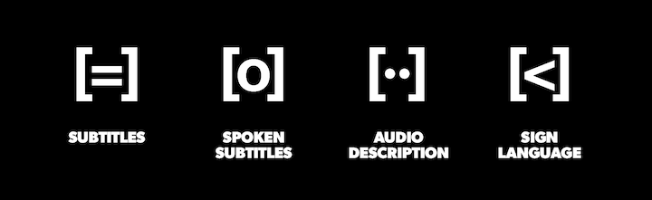

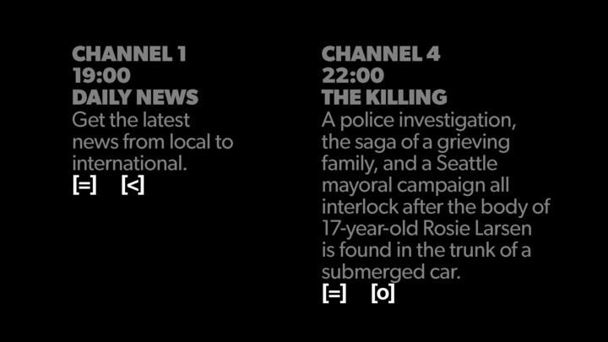

The four icons can be typed on a keyboard - like the classic smiley :-)
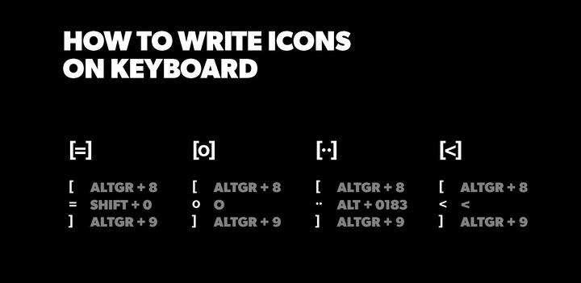
The icons appear everywhere - on listings in print media, web tv, streaming tv, info channel, etc.
How to type an icon
- Choose a sans serif typography in bold version (ex. Arial, Helvetica)
- Enter the desired icon:
- Use contrasting colours to maximize readability (ex. black and white)
[=] AltGr + 8 Shift + 0 AltGr + 9
[o] AltGr + 8 Shift + o AltGr + 9
[··] AltGr + 8 Alt + 0183 Alt + 0183 AltGr + 9
[<] AltGr + 8 < AltGr + 9

Annex B: Links for reference and more information
https://www.skyaccessibility.sky/
https://dtg.org.uk/resource/u-book-4/
https://www.gari.info/
https://www.etsi.org/human-factors-accessibility/en-301-549-v3-the-harmonized-european-standard-for-ict-accessibility?jjj=1716971215908
https://www.dr.dk/om-dr/about-dr/smart-icons-design-common-european-standardization

