NorDig Accessibility friendly remote control
Specification of TV remote control for people with disabilities

1. Introduction
Specification of accessibility friendly remote-control for accessibility services that can be used by users with different types of disabilities for easier access of tv accessibility services.
The accessibility friendly remote-control shall have a simple design and without technical challenges for the consumer to find, connect and access accessibility services on the TV/IRD.
Accessibility friendly remote-control means, a remote control with buttons / physical user interface (including sounds) for the specific standardised accessibility services such as subtitles for hard of hearing, spoken subtitles, audio description etc.
Note: NorDig can specify an accessibility friendly remote-control for accessibility services but will not be commercial involved in a production of a remote-control product.

2. Background
It is often difficult for people with physical disabilities to access accessibility services with an ordinary remote control as it requires interaction with the screen and setup in special menus.
The trend of modern remote-control designs that have a minimum of buttons can make it impossible for users with disabilities to access the accessibility services.
Help is often required from people who are not disabled to find and select accessibility services for those who need them.
It makes it even more difficult / impractical that it´s not always possible to create a fixed setup in an IRD with a usable accessibility profile, so for example, an accessibility service disappears when switching from one TV channel to another.
New technical developments that provide opportunities for better accessibility services on broadcast, online and Ondemand programs does not bring much benefit if users cannot find the services, therefore it is crucial to have a accessibility friendly remote-control.

3. How to / what to
Design requirements for an accessibility remote control to support needs for:
- For the blind and visually impaired.
- For the deaf and hard of hearing.
- For the elderly citizen with reduced motor abilities.
To specified requirements for the physical design with button types, sizes and functions.
A challenge can be e.g. how does the visually impaired person know whether a service is on/off when the user cannot see details on the screen.
Specification of Buttons on the remote-control for accessibility services:
AD button: to access Audio Description and Spoken Subtitles
Subtitle button: to access HF subtitles
Specification of Sounds / “talking remote-control”: TBD
Specification of Layout design: TBD

4. Input for the specification
UK Digital TV Usability and Accessibility Guidelines, including Text to Speech
The ‘U-Book’ Version 4.0
Reference to A1 Remote Control Implementation Guidelines?

A1.11 Voice control of receiver functions
Voice control of receivers can be provided through voice remote controls or other voice assistants. Where remote controls are used that require a button to be pressed before the voice system operates, consideration should be given to users who have reduced motor skills.

A1.4.15 Subtitles
This button should toggle between displaying subtitles (if available with the selected service) and not displaying them. The function should be available directly from the remote control. Note that the receiver should maintain the selected state ("display"/"don't display" subtitles) across channel changes unless otherwise determined by a user-setting in a suitable set-up menu.

A1.4.11 Audio Description
This button should control the decoding of Audio Description (AD) if available with the selected service and event and if the receiver supports AD. The button should toggle between presenting AD mixed with programme sound or just presenting programme sound. The receiver may be capable of directing the mix to independent audio outputs (e.g. phono and/or headphone), in which case this function controls the relevant output. The function should be available directly from the remote control if the receiver supports AD. If selection of AD requires accessing a setup screen, it is recommended that AD be the dominant item so as to simplify selection by a user who cannot see the screen clearly. The digital receiver should maintain the selected state ("present AD"/"don't present AD") across channel changes unless otherwise determined by a user-setting in a suitable set-up menu.

A1.5 Voice Control
This button should activate/deactivate a voice control microphone incorporated into the remote control.
A1.10.3 Spoken input
Some solutions allow for spoken input (using automatic speech recognition, ASR) as an alternative to text input. This can improve the accessibility of text entry for some categories of disabled people, but this is not a solution that will work for all users and should therefore not be seen as the sole alternative to standard input methods.
A combination of a voice control facility for text entry and a text to speech function for confirmatory feedback of text entered can be beneficial to visually-impaired users.
A1.10.4 Text-to-speech assisted input
Some users, in particular blind and partially-sighted users, may benefit from text entry using the numeric keys on the remote control assisted by the text-to-speech engine. As characters are entered, the text-to-speech engine provides spoken feedback on the text entered.
See Part B, Chapter 3: “Text to Speech translation” for more information about the text-to-speech function.
A1.11 Voice control of receiver functions
Voice control of receivers can be provided through voice remote controls or other voice assistants. Where remote controls are used that require a button to be pressed before the voice system operates, consideration should be given to users who have reduced motor skills.
A1.12 Other considerations
Where a remote control is based on the use of a touch screen, this should not be the only means of controlling the receiver: the use of such devices can be difficult for those with limited control of hand movements or single-handed.
A2.2 User documentation
A2.2.1 General
User guides should be easy to read, concise and jargon-free (using plain English). They should avoid technical abbreviations and have a design and content that will be accessible to most users.
For general guidance on best practice in documentation, see the guide “How to write in plain English” [1]. The process of applying for the Plain English Campaign’s Crystal Mark will also help in producing a document that can be read, understood, and acted upon by the intended audience.
The user guide should comprise at least a Quick Start Guide and a main user guide. Best practice is for these to be separate documents.
If there is also a copy of any written documentation online, this should be provided in an accessible HTML or PDF file format. This will enable the user to change the text size within the document to suit individual preferences as standard. HTML documents and text-based PDF files can usually be read by assistive technology such as screen readers.
It can be beneficial for users who find text inaccessible to have access to instructions as an audio file, with descriptions in place of diagrams.
A2.2.8 Accessibility
The user guides should provide information about the accessibility features of the product and about access services such as subtitling and audio description, ideally in a separate accessibility section.
A2.4.2 Accessibility statement
Where a product has been specifically designed for given user groups (for example a product has many of the features related to visually-impaired people as covered in this document), it may be useful to include a statement declaring this and listing the specific features and behaviours intended to support this user group. This could be of value to those purchasing receivers online without the benefit of demonstration or advice from sales staff.
Where present, the accessibility statement should be included at the start of the user guide.
A2.6 Electronic user guides
For complex and multi-function products alternatives to the printed user guide may be appropriate if the printed guide becomes unacceptably large (e.g. over 100 pages).
Here a best practice approach is to provide a printed introductory user guide, additional to the QSG, describing the basic features and operation such that the consumer can use the equipment for receiving and viewing the main services and main functions. This short guide should also contain clear instructions on how to access and use the on-screen guide. The more detailed instructions could then be provided on-line or on a supplied electronic storage device.
If a user guide is provided in electronic form then the following criteria should apply:
It should have a comprehensive interactive index that allows the user to navigate to the required section or topic.
It should have an interactive content or text search facility, and a context-sensitive help tool when the receiver is in use, to take the user to the appropriate section of the guide.
Where the user guide is provided on the associated display it should be in an interactive format such that any instructions being given can be carried out without the user having to exit the guide.
The presentation of the electronic guide should be consistent with the display technology, e.g. using established website design principles. Font size and line spacing of text should be appropriate for TV screen viewing. The use of annotated or animated diagrams may help explain technical issues.
It should be available in an accessible format, e.g. large text.
It should also be possible for the user guide to be printed out or otherwise available in printed or audio form (using a natural voice) on request.
A4.4 Electronic Programme Guide (EPG)
General information on the practices to be followed by EPG providers can be found in a Code of Practice published by Ofcom3.
To benefit users with impaired vision and hearing, a receiver should facilitate:
rendering the text needed for EPG navigation and the provision of information on channels and programmes included in the EPG as speech;
highlighting in the EPG display or listing separately programmes with audio description (and with signing, for users with hearing impairments);
selection of a ‘high contrast’ display
adjustment of the display of EPG information so that it can be magnified, or the text enlarged.
The following sections give detailed information on best practice for a satisfactory user experience. Information on design for legibility can be found in Chapter 5.
A4.8.2 Subtitles and Audio Description (AD)
When subtitle or AD mode is active it should remain active when channels are changed.
Part A
A4 The user interface
Programmes that carry subtitles, signing and/or AD should be clearly indicated in the EPG and Info or mini guide displays so that the user can identify them without having to hunt for them: e.g. they can be highlighted directly on the EPG display or by automatic display of the ‘info’ data as the user scrolls through the EPG or Info. The appropriate official icons should be used4.
Programmes that support AD should be identified additionally by differing audible signals (e.g. beep) when AD mode has been globally selected and deselected and when a current AD event is selected. The different signals used should be easily identifiable by all users.

5. Icons for accessibility services
DR smart icon design.
Developed in 2013 and implemented in 2014 in EPG, Onscreen and in all printed media / papers in Denmark, presented for EBU at Madrid meeting 2018 as proposal for common standard.
https://www.dr.dk/om-dr/about-dr/smart-icons-design-common-european-standardization

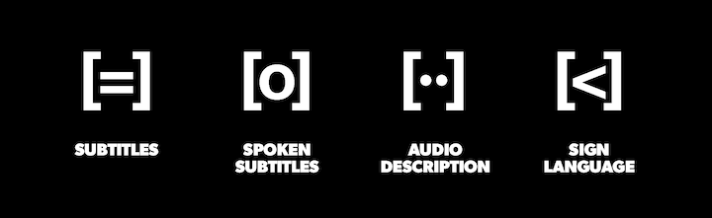

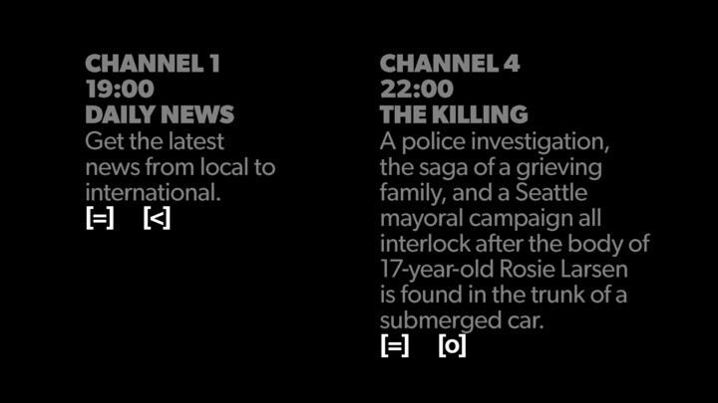

The four icons can be typed on a keyboard - like the classic smiley :-)

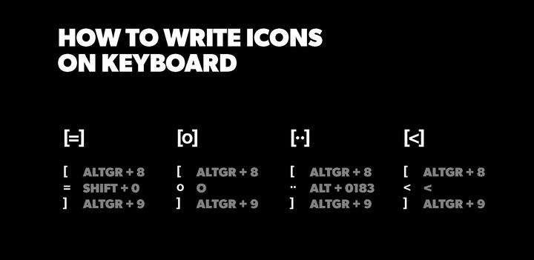

The icons appear everywhere - on listings in print media, web tv, streaming tv, info channel, etc.

How to type an icon
- Choose a sans serif typography in bold version (ex. Arial, Helvetica)
- Enter the desired icon:
- Use contrasting colors to maximize readability (ex. black and white)
[=] AltGr + 8 Shift + 0 AltGr + 9
[o] AltGr + 8 Shift + o AltGr + 9
[··] AltGr + 8 Alt + 0183 Alt + 0183 AltGr + 9
[<] AltGr + 8 < AltGr + 9

6. Universal interface for the Accessibility friendly remote-control
There are universal remote controls on the market that communicate with IRD / TV receivers via IR communication, but almost every product type and model have different IR protocols so the user must find the specific IR protocol for exactly the device that the user has, which can be difficult.
Since the IR communication solution has proven to be outdated, the goal is to develop an API that can work across all IRD / TV receiver products.

7. Links for inspiration / information:
https://www.skyaccessibility.sky/
https://dtg.org.uk/resource/u-book-4/
https://www.gari.info/
https://www.etsi.org/human-factors-accessibility/en-301-549-v3-the-harmonized-european-standard-for-ict-accessibility?jjj=1716971215908
https://www.dr.dk/om-dr/about-dr/smart-icons-design-common-european-standardization

